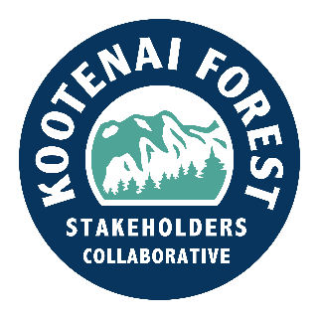

Thank You to Ryan Zinke

To the Editor,

There is a lot of uncertainty today about our public lands, and whether we are going to be able to manage them effectively in the next few years. We have seen chaotic firings of Forest Service and other agency workers, some staff reinstatements followed by more firings, together with vague promises of major structural changes coming to the FS. There is reason to wonder whether we are going to be able to do the essential work on our public forest lands to reduce fire risk, harvest timber, improve wildlife habitat, and fight wildfires.

An even more ominous threat appeared recently, when a measure in a proposed big Republican budget bill called for selling some 500,000 acres of public land in Neveda to the highest bidder. This measure represented not only the loss of public access to these lands, but also a dangerous precedent that could lead to more public land sales in the future.

We are proud that our entire Montana Congressional delegation opposed this measure. Ryan Zinke deserves special credit for organizing a bipartisan Public Lands Caucus in the House, together with Democratic Congressman Vasquez from New Mexico.

Zinke was under great pressure from Republican leadership to support the House bill including the land sale measure, but he insisted he would not vote for the bill until the land sale provision was removed. It took a lot of courage for Zinke to take this stand, and the bill eventually passed without the mandate to sell off the public land.

The members of the Kootenai Forest Stakeholders Collaborative are most concerned about what is in store for the public lands that surround our communities. We are relieved and encouraged to see our Montana congressional delegation stand up to prevent the large scale sale of our public lands. All Montanans, and Americans everywhere who value our public lands, owe a big thank you to Zinke for standing his ground on this issue.

Tim Dougherty and Doug Ferrell

Co-chairmen, The Kootenai Forest Stakeholders Collaborative